**Convoy Office Admin Tools**

**(COAT)**

**Enhancement Functions**

**July 2014**

**User Menu**

**Table of Content**

Introduction 3

Access Card Request 4

ADM Service Request 5

Key Request 6

Company Asset Request 7

Room Setting Request 8

**Introduction**

We are glad to announce the COAT Administration Platform Enhancement is ready for use. Those NEW Added Function embedded in the “eConvoy > Tools > Office Admin”, in which you can place order of Access Card / Photo Sticker, Keys, requesting Company Asset & Room Setting and reporting Repair & Maintenance services in office area.

With COAT, your requests will be done electronically instead of filling physical forms. It serves your convenience and a Green office. The history of your requests can also be viewed in the COAT.

Staff / Consultant may access through **(eConvoy 🡪 Tools 🡪 Office Admin)**

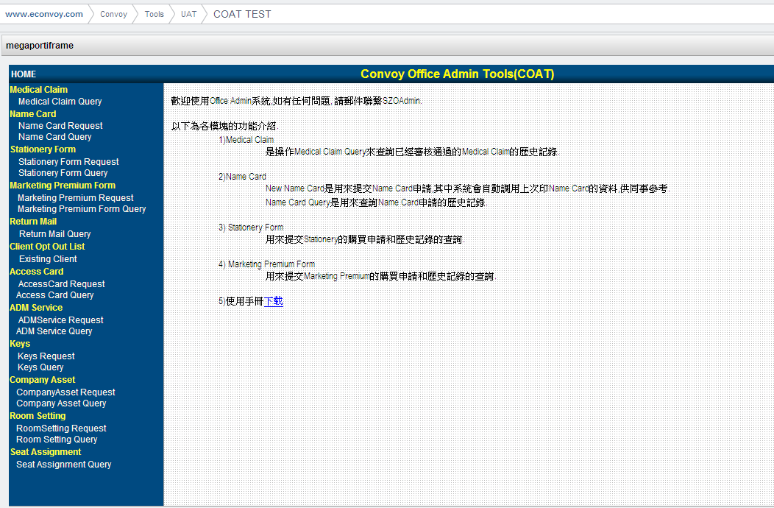

**Access Card / Photo Sticker Request**

*For loss or request to replace access card and photo sticker*

How to Apply

eConvoy 🡪 Tools 🡪 Office Admin🡪Access Card Request

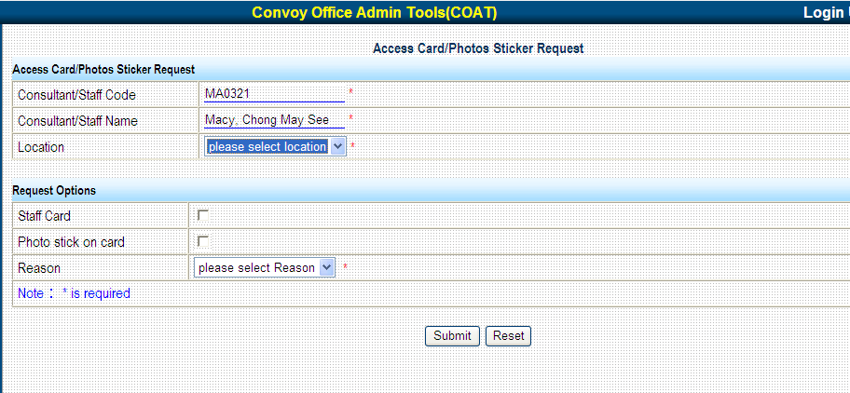

2. Select the item you need and choose a reason.

3. Press the submit button

1. Staff code & Name are default according to your login, please choose location only

Access Card Query

eConvoy 🡪 Tools 🡪 Office Admin🡪Access Card Query

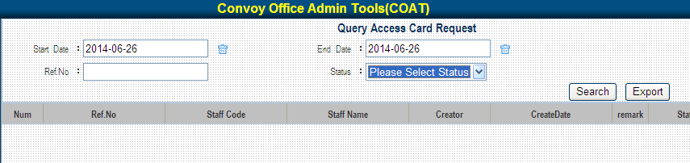

You may search by Request Date, Ref No., Status or even export an excel list to show all your request history.

**ADM Service Request**

*For reporting repair & maintenance services in office area and Phone problems.*

How to Apply

eConvoy 🡪 Tools 🡪 Office Admin🡪ADM Service Request

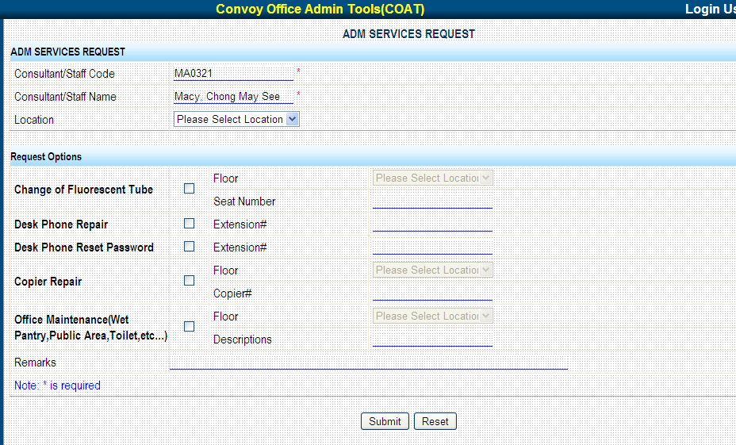

2. Select the item you need to report

3. Press submit button

1. Staff code & Name are default according to your login, please choose location only

ADM Service Query

eConvoy 🡪 Tools 🡪 Office Admin🡪ADM Service Query

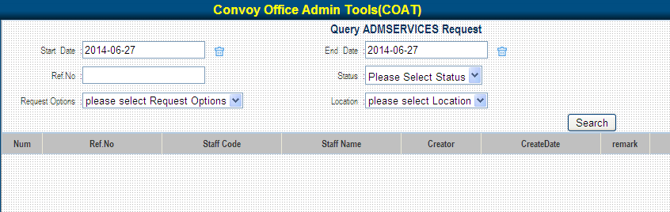

You may search by Request Date, Ref No., Request Options, Status or even export an excel list to show all your request history.

Keys Request

*For request replacement of locker, desk drawer & pigeon box key*

*Due to the security reason, requestor only allows to apply the keys of their official assigned seat.*

How to Apply

eConvoy 🡪 Tools 🡪 Office Admin🡪Keys Request

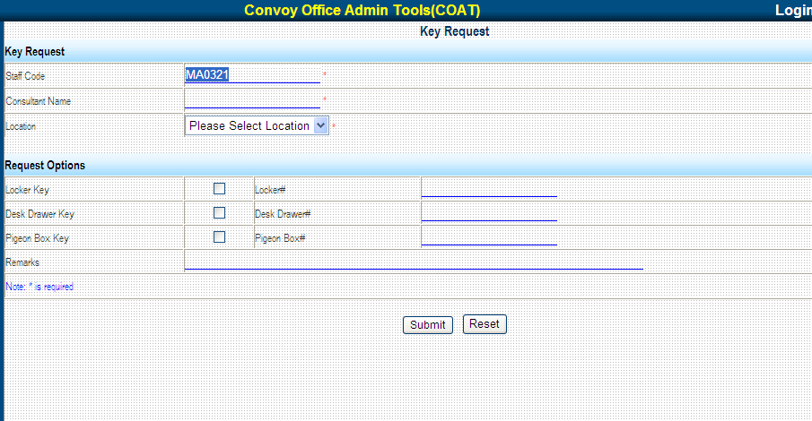

1. Staff code & Name are default according to your login, please choose location
2. Select the key you needed
3. Press the Submit button

Keys Query

eConvoy 🡪 Tools 🡪 Office Admin🡪Keys Query

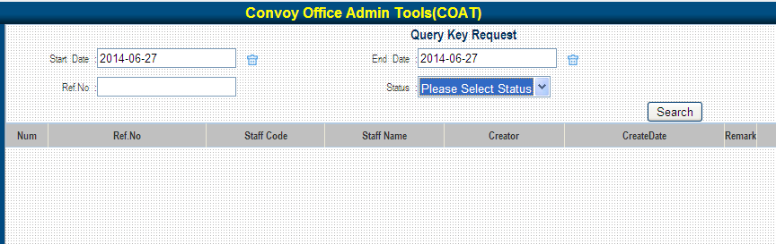

You may search by Request Date, Ref No., Status or even export an excel list to show all your request history.

Company Asset Request

*For Company Asset (Banner, 易拉架, Sales Booth, etc…) borrow*

How to Apply

eConvoy 🡪 Tools 🡪 Office Admin🡪Company Asset Request

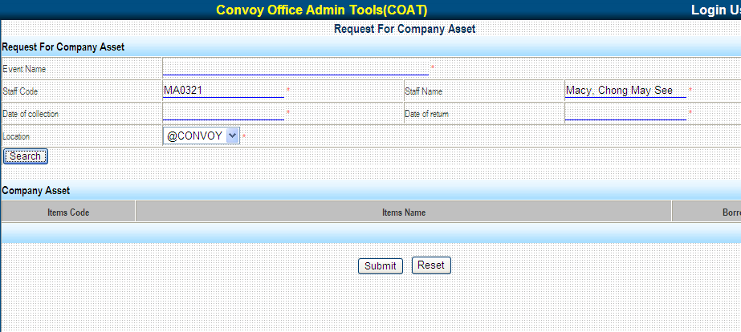

1. Fill in the Event Name, Date of Collection & Date of Return
2. Press the Search button

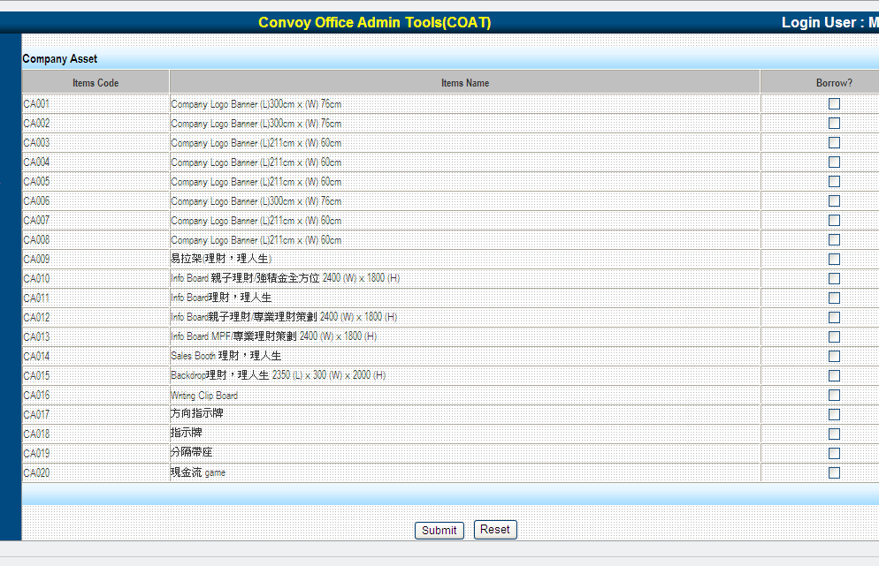

1. Select the request items
2. Press the Submit button

Room Setting Request

*For combine room at 5/F @CONVOY & 17/F City Plaza 3*

How to Apply

eConvoy 🡪 Tools 🡪 Office Admin🡪Room Setting Request

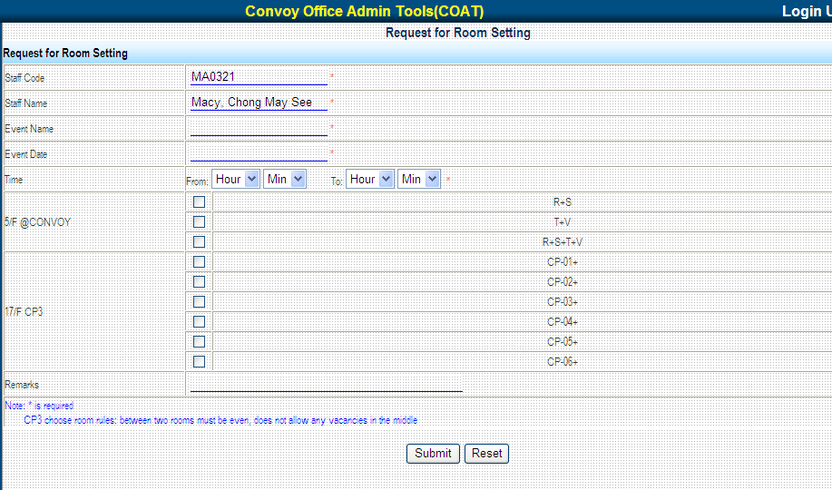

1. Fill in the Event Name, Event Date & Time.
2. Select the request combine room number
3. Press the Submit button.

Room Setting Query

eConvoy 🡪 Tools 🡪 Office Admin🡪Room Setting Query

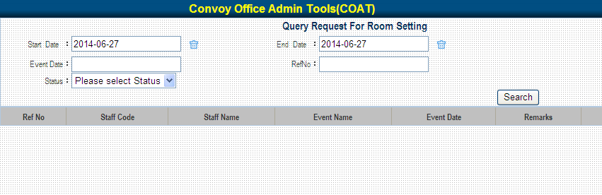

You may search by Request Date, Ref No., Event Date, Status or even export an excel list to show all your request history.